HOME
Ky tekst:
2XAR represents the intersection of technical precision and visionary engineering. We focus on four core sectors: Buildings, Infrastructure, Water, and Roads. We move beyond conventional construction to develop complex infrastructure that powers regional economies and defines the architectural standards of the Western Balkans.

Based in Prishtina, our 25-year legacy is built on a foundation of absolute reliability. We integrate advanced civil engineering with strategic project management to deliver high-impact works that stand the test of time and support regional growth.
Zevendesohet me:
2XAR represents the intersection of technical precision and visionary engineering. We operate across four core sectors: Buildings, Infrastructure, Water, and Roads - delivering complex projects that power regional economies and shape the built environment of Southeast Europe.

With headquarters in Prishtina, and offices in Tirana, Podgorica, and Skopje, 2XAR brings together a team with extensive experience developed over three decades across multiple sectors and geographies, including Southeast and Western Europe. This foundation allows us to combine advanced engineering with disciplined project execution, delivering infrastructure defined by reliability, performance, and long-term value.

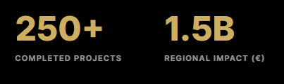

Ne vend te 250+ e ben 150+
Ne vend te 1.5B e ben 350M

----
Our network spans across **Italy, Germany, Greece, Turkiye, Azerbaijan, Lebanon, Kuwait, China, India, North Macedonia, Albania, Croatia, etc.**
Internal Financial Institutions: **EBRD, EIB, World Bank, EU funds, KfW, Saudi Fund, Islamic Development Bank, WBIF, etc.**

Çka eshte ne mes te dy yjeve ** behet bold. Dmth hiqen ** dhe fjalet behen bold.
Our network spans across Italy, Germany, Greece, Turkiye, Azerbaijan, Lebanon, Kuwait, China, India, North Macedonia, Albania, Croatia, etc.
Internal Financial Institutions: EBRD, EIB, World Bank, EU funds, KfW, Saudi Fund, Islamic Development Bank, WBIF, etc.

Te News & Insights kemi shtate lajme:

(Por derisa nuk na furnizon ai me fotografi, atehere duhet t’I gjejme qe pershtaten me lajmin si dhe largoji datat)
1. Kosovo Landfills Program

2xAR Awarded Major Environmental Infrastructure Contract in Kosovo
Waste Management & Environmental Systems
PRISHTINA, KOSOVO — 2xAR, a regional leader in infrastructure and environmental engineering, has been awarded a landmark €40 million contract for the development of a national landfill and waste management system in Kosovo.
This project represents a critical step toward strengthening environmental protection and aligning national waste infrastructure with European Union standards.
The scope includes the design and construction of modern landfill facilities, advanced waste processing systems, and environmental protection measures to ensure long-term sustainability.
“This project is a strategic investment in environmental responsibility and public health. It reflects our commitment to delivering infrastructure that creates lasting impact.”

Engineering for Sustainability
The project will incorporate advanced environmental safeguards, including:
- Groundwater protection systems
- Methane management solutions
- Long-term environmental monitoring infrastructure
These systems are designed to minimize environmental impact while ensuring compliance with EU regulations.

Strengthening Environmental Infrastructure
Execution will involve close collaboration with international partners and local stakeholders, utilizing modern construction methodologies and digital project management tools to ensure precision and efficiency.

2. Berane – Rozhaje Corridor

2xAR Secures €53.4M Contract for Strategic Transport Corridor
Road Infrastructure & Connectivity
BERANE, MONTENEGRO — 2xAR has been awarded a €53.4 million contract for the development of a key section of the Berane–Rozhaje corridor, a project of strategic importance for regional connectivity in Montenegro.
The project includes the construction of high-capacity road infrastructure, engineered to improve traffic flow, safety, and economic integration within the region.
“This corridor is a critical link for regional development. Our focus is on delivering infrastructure that enables long-term economic growth and connectivity.”

Engineering for Performance
The works include:
- Advanced road construction systems
- Structural reinforcement for long-term durability
- Integrated drainage and environmental protection systems

Regional Impact
Once completed, the corridor will significantly improve transport efficiency and strengthen cross-border mobility across Southeast Europe.

3. Shtip Infrastructure Project

2xAR Advances €32.5M Infrastructure Development in Shtip
Urban Infrastructure & Utilities
SHTIP, NORTH MACEDONIA — 2xAR is leading the development of a €32.5 million infrastructure project in Shtip, focused on upgrading urban systems and utility networks.
The project includes the modernization of road networks, utility infrastructure, and supporting systems designed to enhance urban functionality and long-term sustainability.
“Urban infrastructure is the backbone of economic development. This project is designed to support the future growth of Shtip and its surrounding regions.”

Integrated Urban Systems
The project includes:
- Road rehabilitation and expansion
- Utility network upgrades
- Drainage and water management systems

Delivering Long-Term Value
The development will improve infrastructure resilience and support long-term urban planning initiatives in the region.

4. Tetovo Infrastructure Project

2xAR Delivers €23M Infrastructure Upgrade in Tetovo
Civil Works & Urban Development
TETOVO, NORTH MACEDONIA — 2xAR is executing a €23 million infrastructure development project in Tetovo, focused on strengthening urban connectivity and public infrastructure.
The project includes major civil works aimed at improving traffic systems, public access, and overall urban efficiency.
“This project reflects our commitment to delivering infrastructure that directly improves daily life and long-term urban performance.”

Enhancing Urban Connectivity
Scope includes:
- Road network improvements
- Public infrastructure development
- Supporting engineering systems

Execution Excellence
The project is being delivered using modern engineering practices and strict quality control to ensure durability and performance.

5. Mojkovac Infrastructure Project

2xAR Awarded €13M Infrastructure Contract in Mojkovac
Regional Development & Civil Engineering
MOJKOVAC, MONTENEGRO — 2xAR has secured a €13 million contract for infrastructure development in Mojkovac, contributing to regional connectivity and economic growth.
The project focuses on upgrading key infrastructure systems to improve accessibility and long-term sustainability.
“Projects like this are essential for strengthening regional economies and improving infrastructure resilience.”

Infrastructure Development
Key components include:
- Road infrastructure upgrades
- Utility system improvements
- Environmental considerations

Supporting Regional Growth
The project will enhance mobility and contribute to long-term development in the region.

6. Viti Water Infrastructure

2xAR Expands Water Infrastructure in Vitia with €6.5M Project
Water Supply & Utilities
VITI, KOSOVO — 2xAR is delivering a €6.5 million water infrastructure project in Viti, aimed at improving water supply systems and supporting sustainable development.
The project includes the construction and rehabilitation of water networks to ensure reliable and efficient service.
“Access to reliable water infrastructure is fundamental. This project ensures long-term service and sustainability.”

Water System Enhancement
The works include:
- Pipeline construction and rehabilitation
- Pumping stations
- System optimization

Sustainable Delivery
The project is designed to meet long-term demand while ensuring efficient resource management.

 7. Mavrovo Environmental Project

2xAR Implements Environmental Infrastructure Project in Mavrovo
Environmental Protection & Sustainability
MAVROVO, NORTH MACEDONIA — 2xAR is delivering a €2.4 million environmental infrastructure project in Mavrovo, focused on sustainability and ecological protection.
The project includes specialized engineering solutions designed to minimize environmental impact.
“Environmental responsibility is integrated into every project we deliver. This initiative reinforces our commitment to sustainable engineering.”

Environmental Engineering
Key features include:
- Ecological protection systems
- Sustainable construction methods
- Environmental monitoring
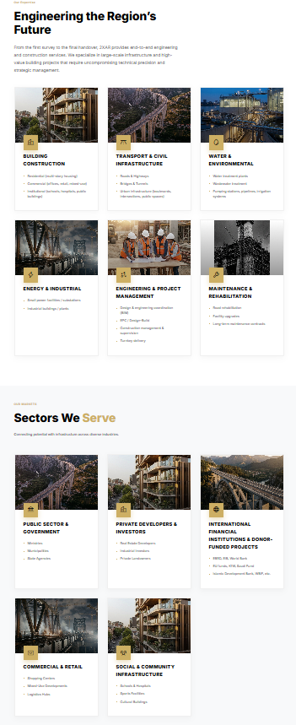
fotot e ngjashme te te dy sektoret. Duhet t’I nderrosh varesisht prej sherbimit.

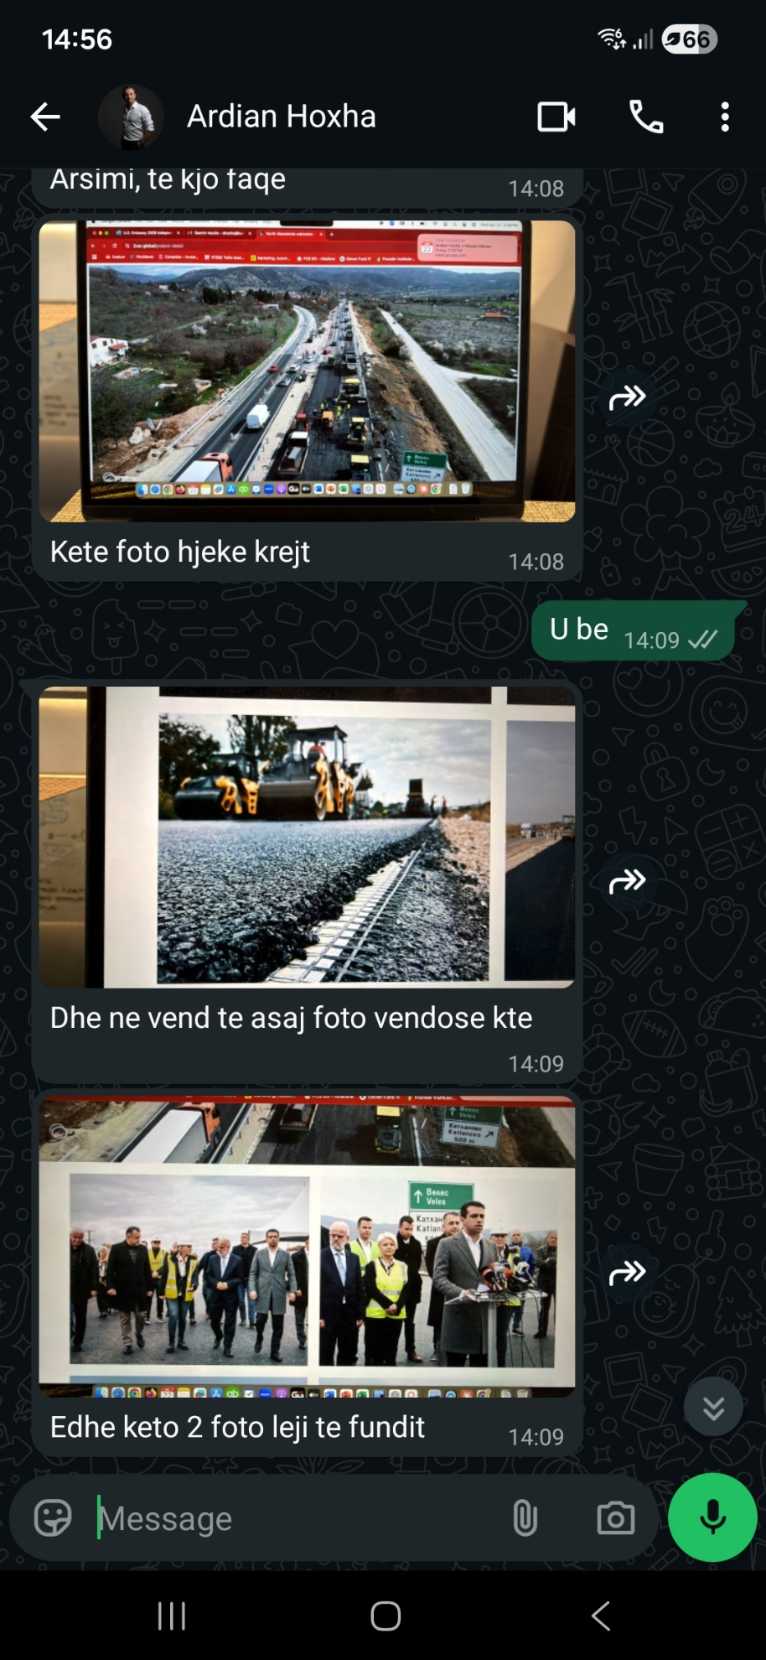

Lere nje space ne mes paragrafave
At 2xAR, we don't just build infrastructure; we build careers. Our culture is rooted in a shared commitment to safety, technical precision, and continuous development.

Working in the Western Balkans with 2xAR offers a unique professional proposition: the opportunity to work on massive, legacy-defining projects for global partners while being at the forefront of the region's modernization.

